**DBMS**

1 List the name and salary of the employees whose salary is more than 1000.

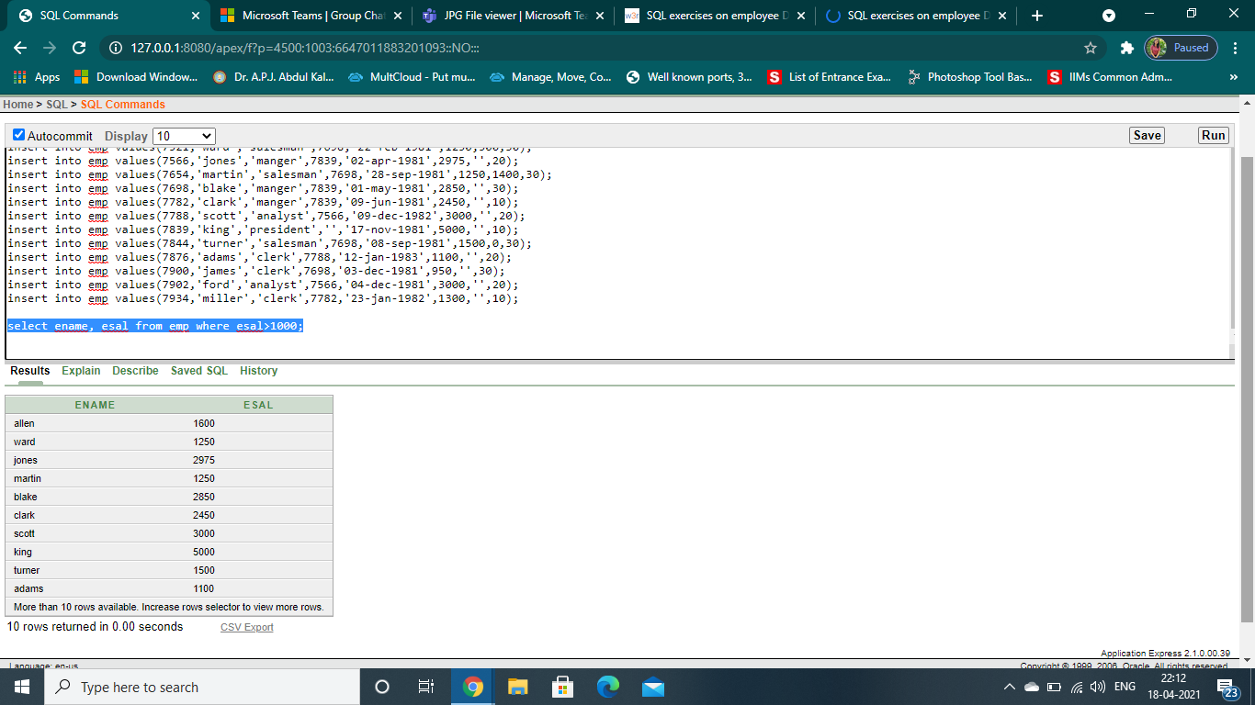

2. List the names of the clerks working in the department 20.

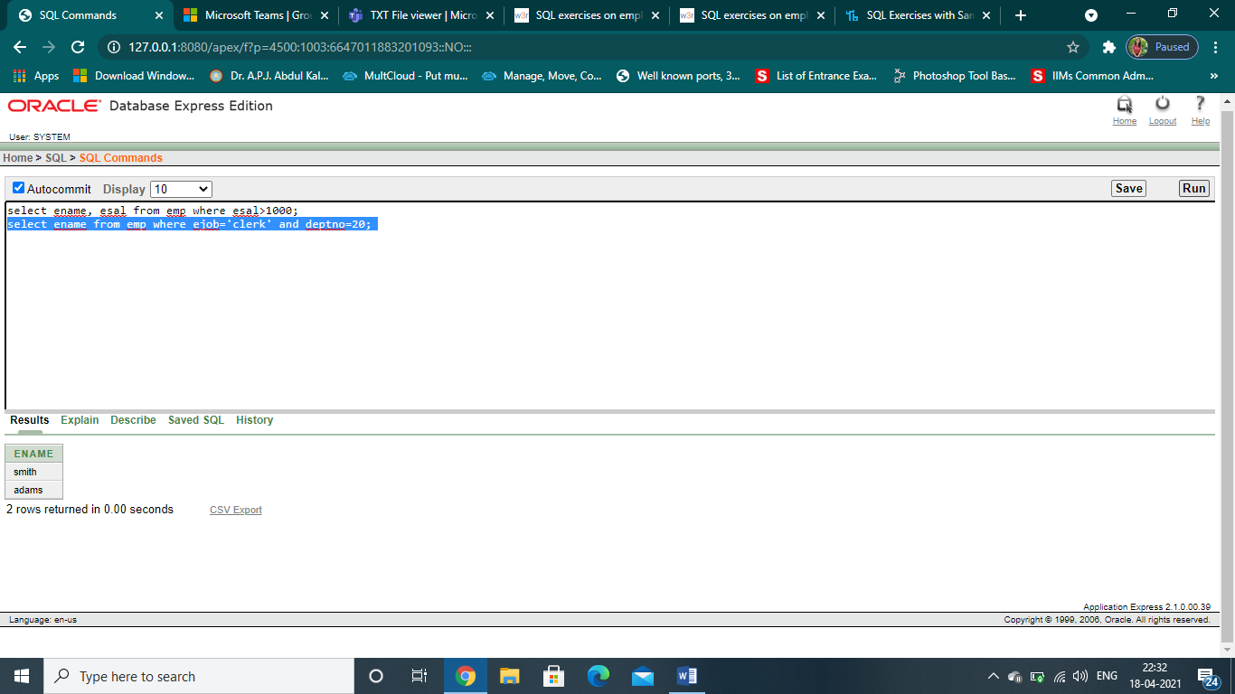

3. List the names of analysts and salesman

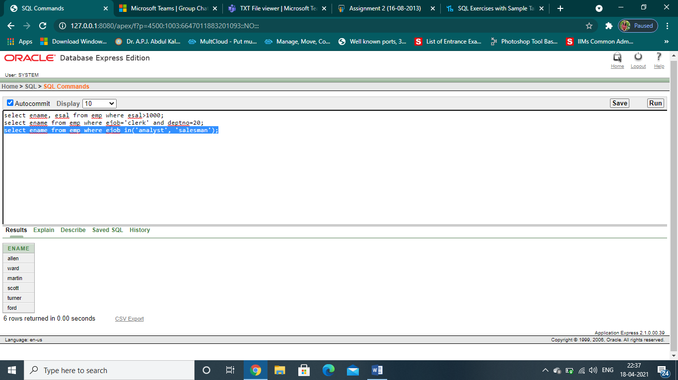

4. List the names of employees who are not manager

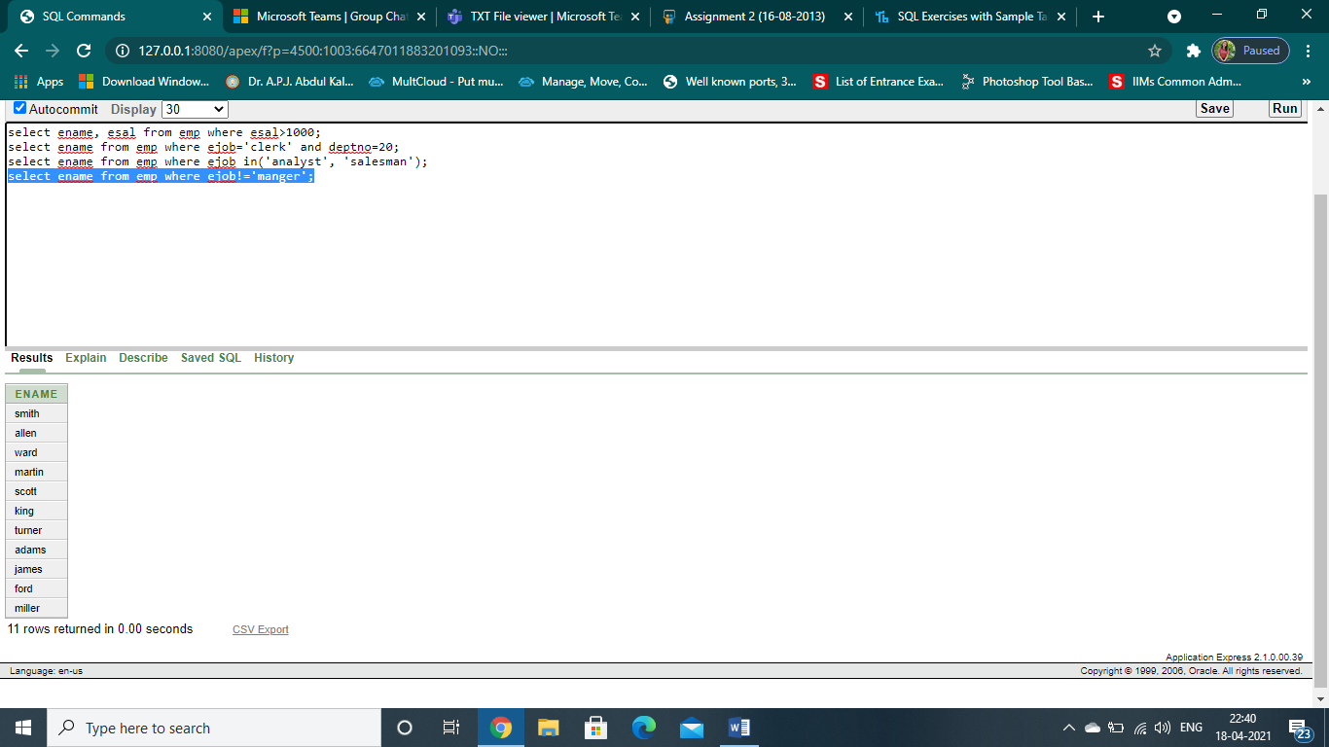

5. List the details of the employees who have joined before the end of September 81.

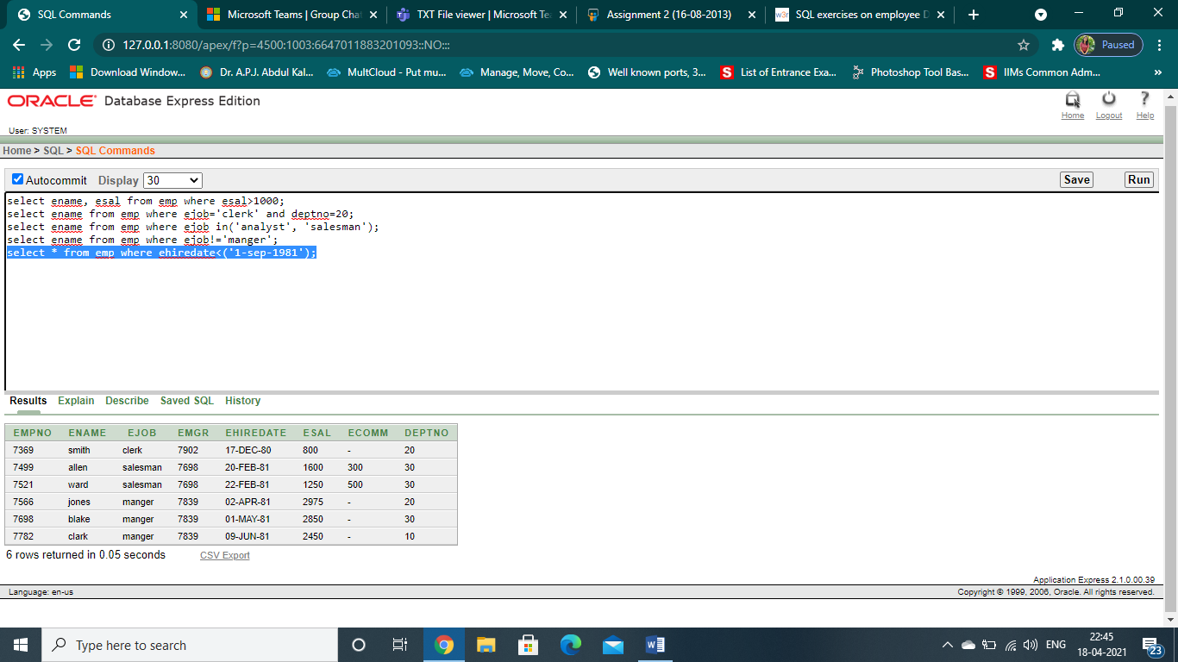

6. List the names of the employees whose employee numbers are

7369, 7521, 7566, 7782

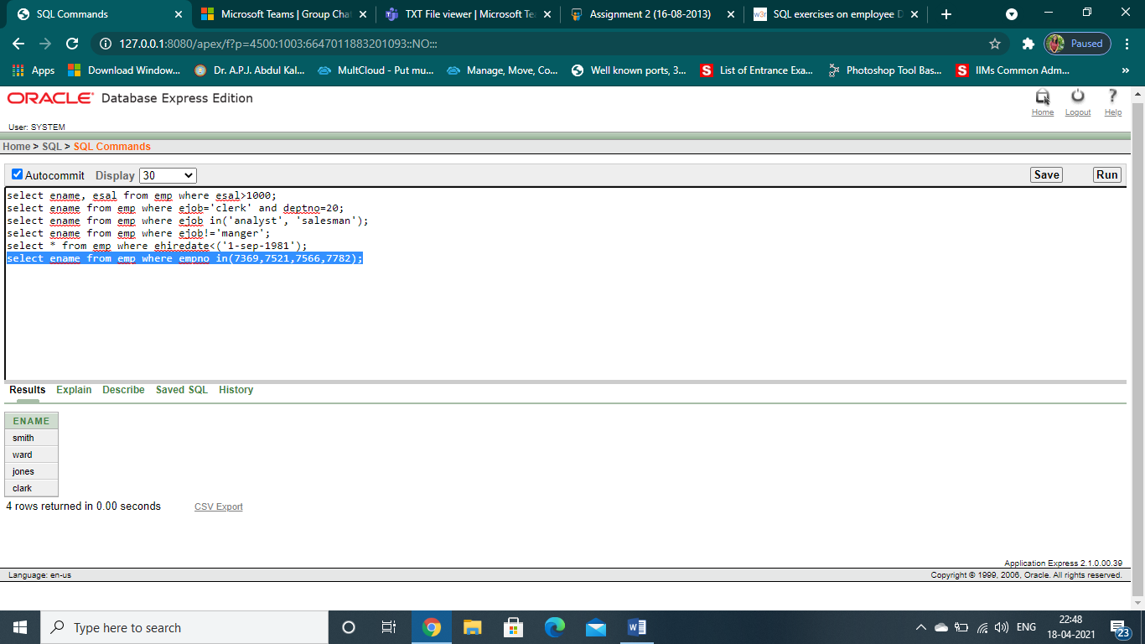

7. List the names of the employees not belonging to the department 10 and 20

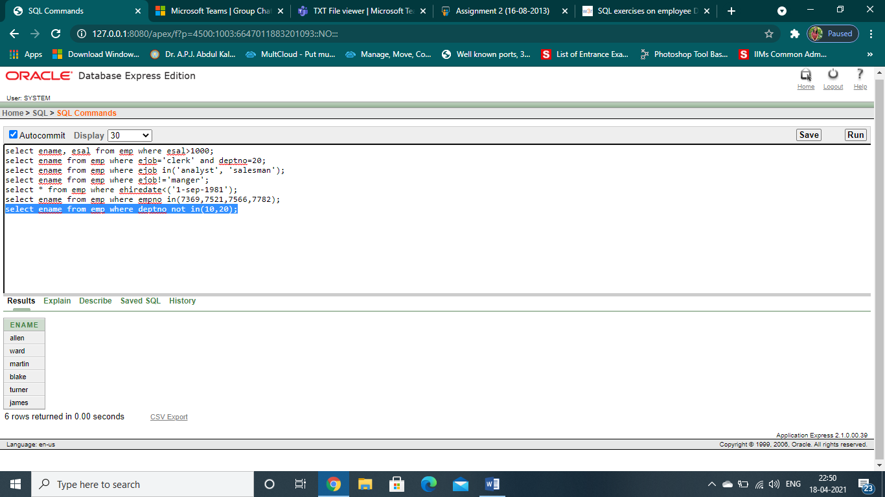

8. List the employees name and salary , whose salary is between 1000 and 2000

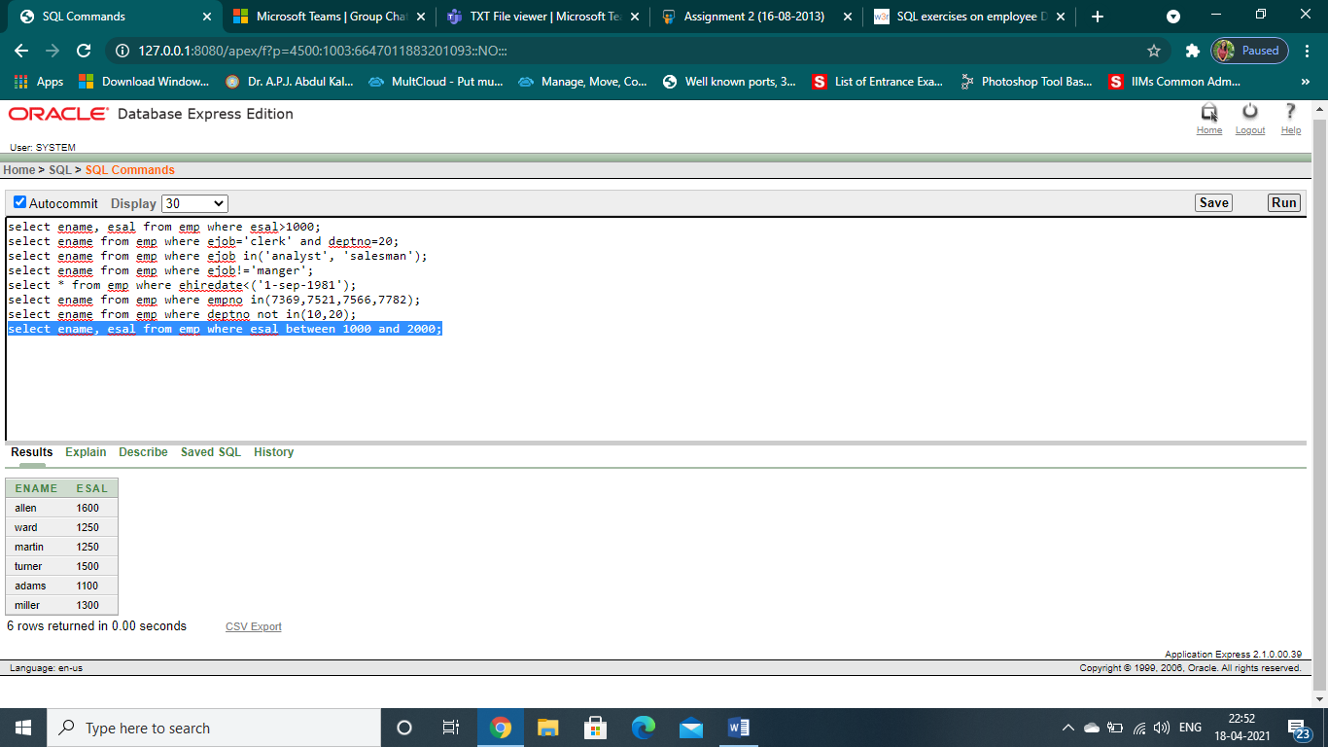

9. List the different jobs available in the emp table.

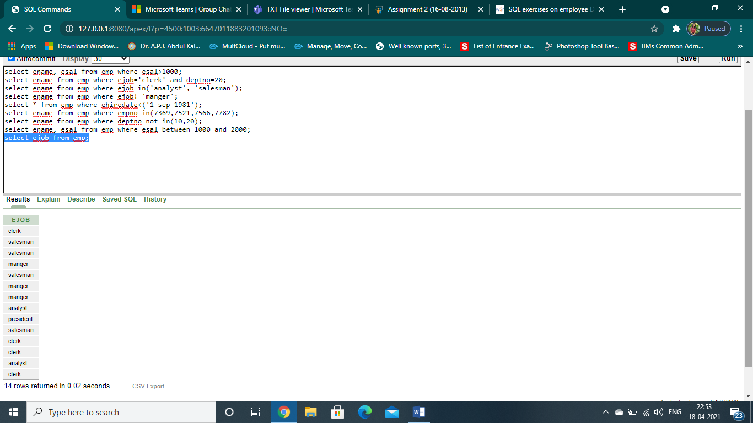

10. List the details of employees whose salary is greater than 2000 and commission is null.

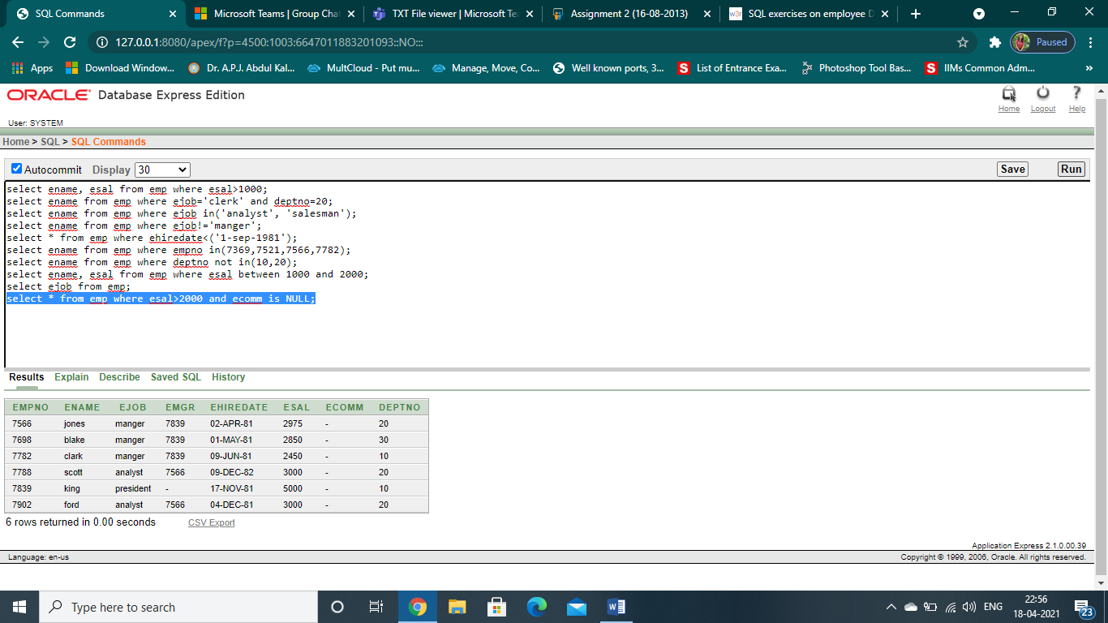

11. List the employees who are not eligible for commission

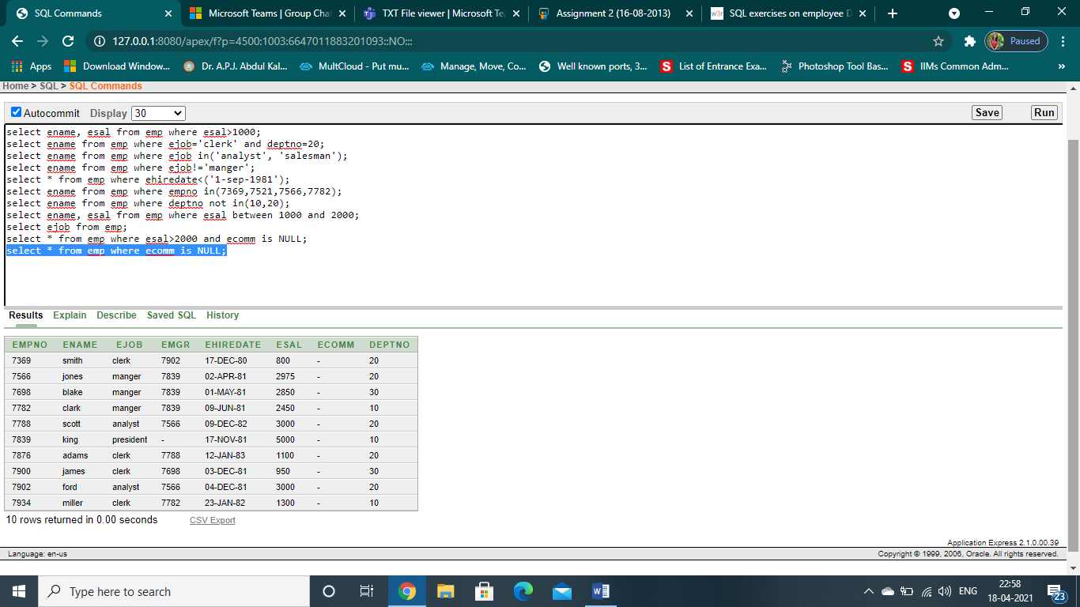

12. List all the employees who are eligible for commission

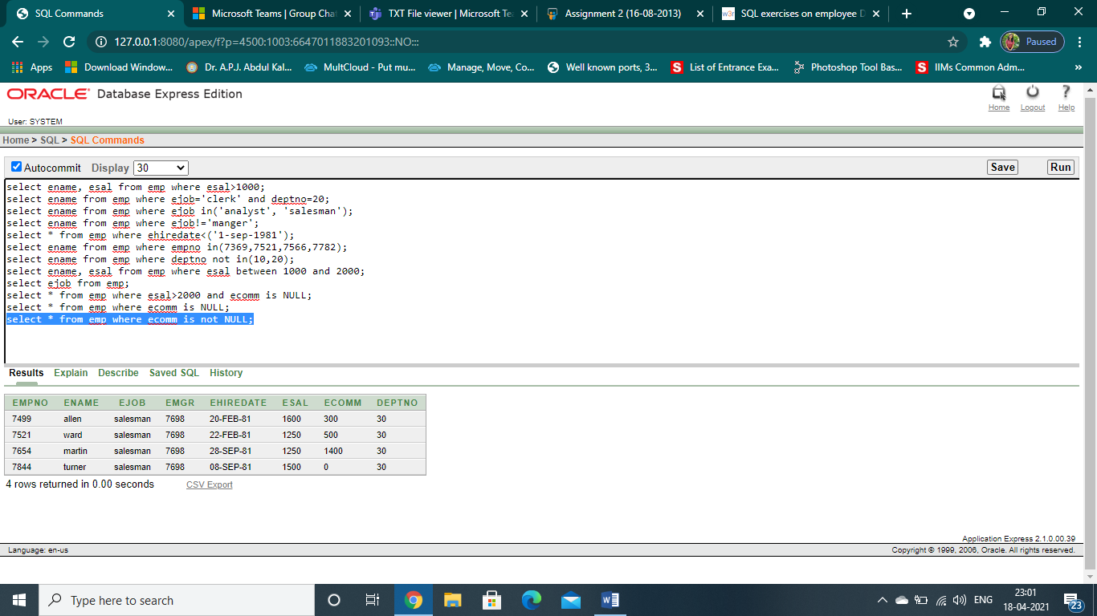

13. List the name of the emplohyees whose name start with ‘s’

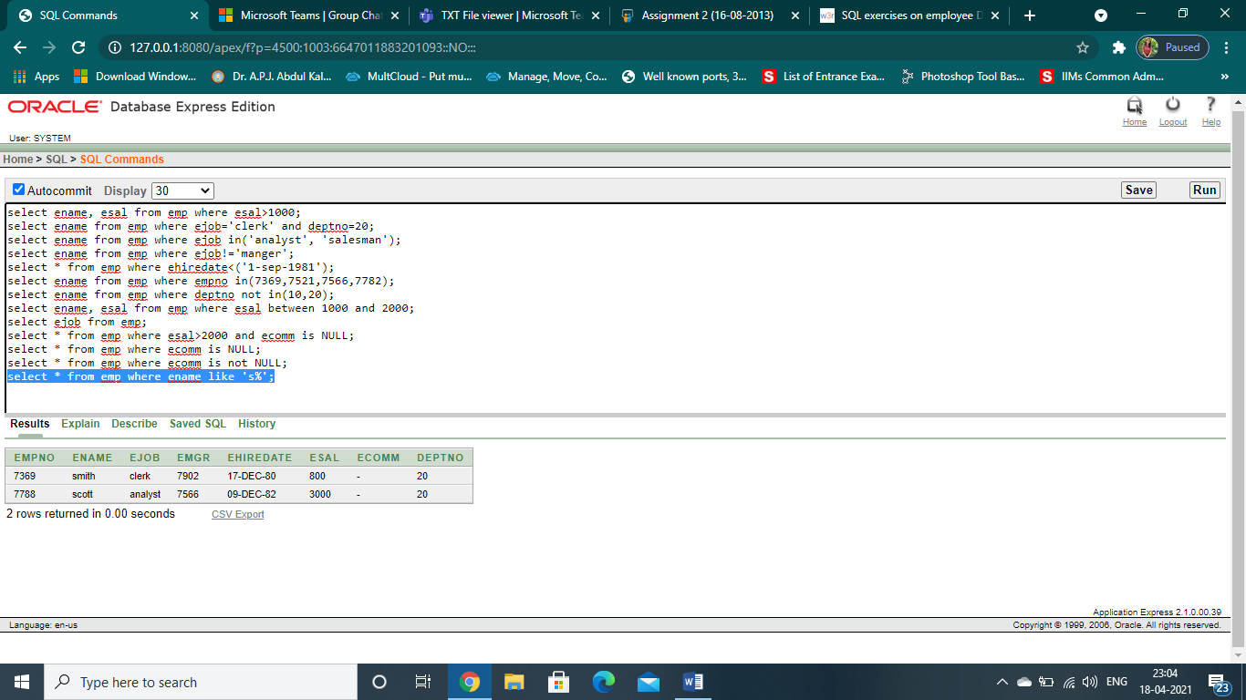

14. List the employees names having ‘I’ as the second character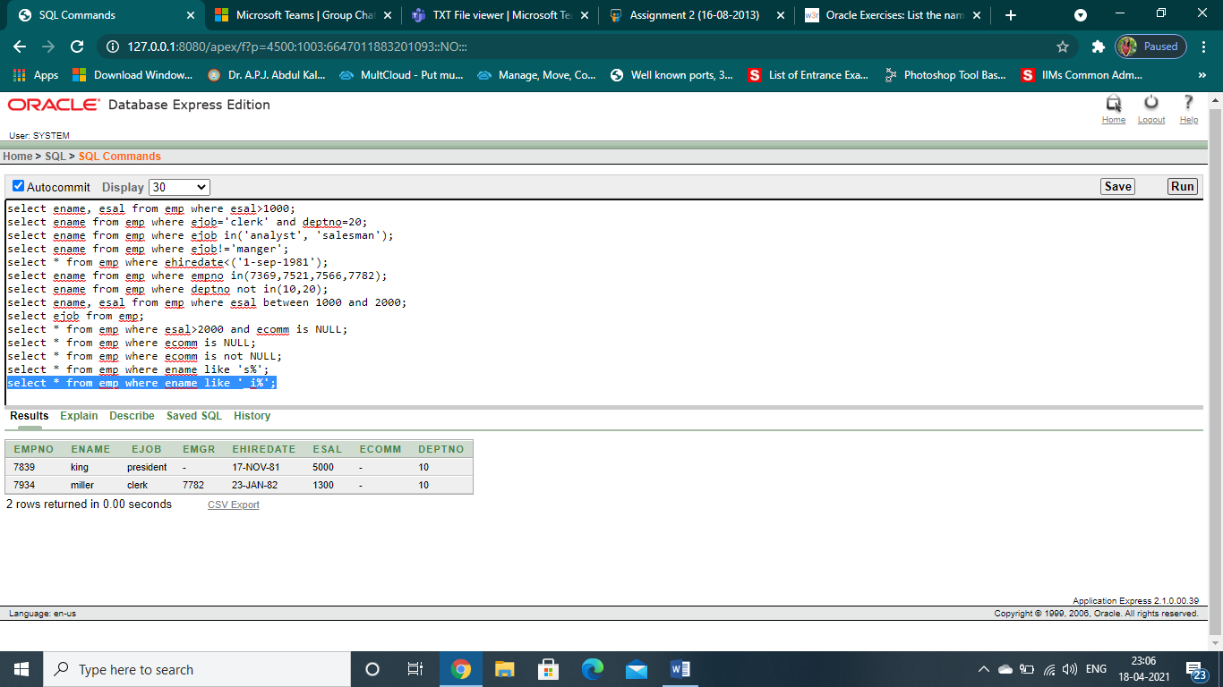

15. List the name , salary and PF amount of all the employees

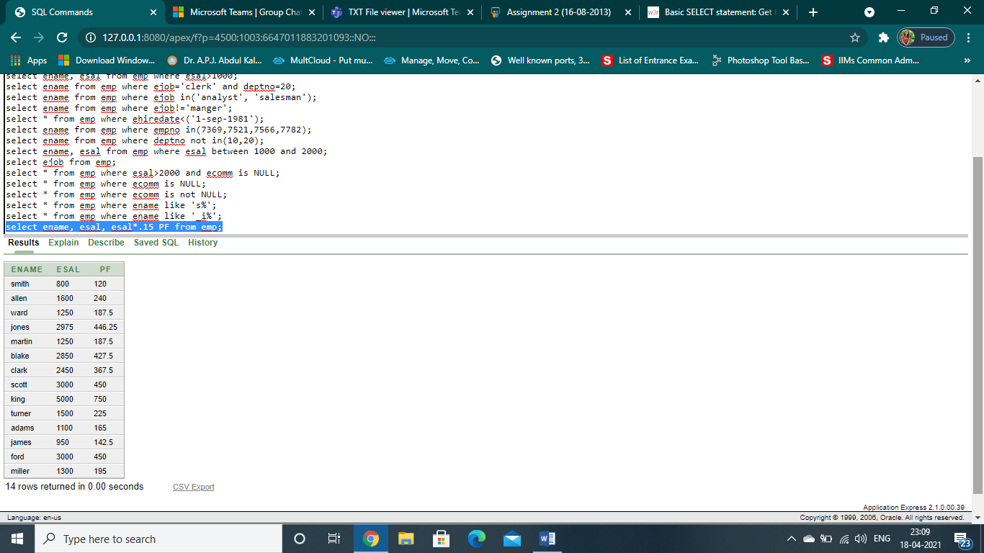

16. List the empno, name, sal in ascending order of salary

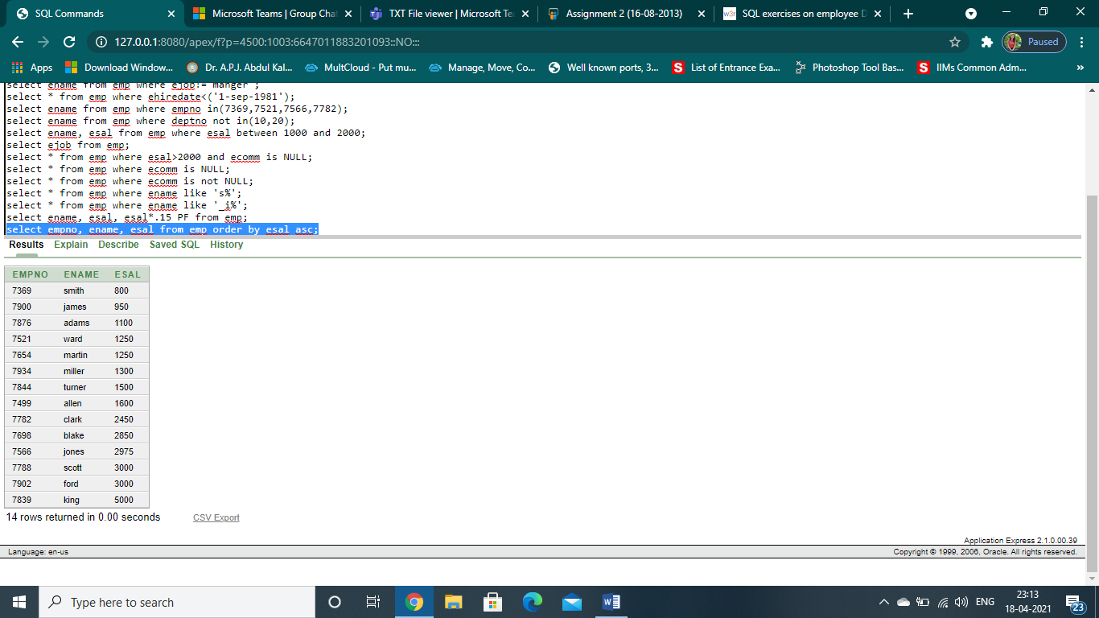

17. List the employees name and date of joining in descending order in order of date of joining

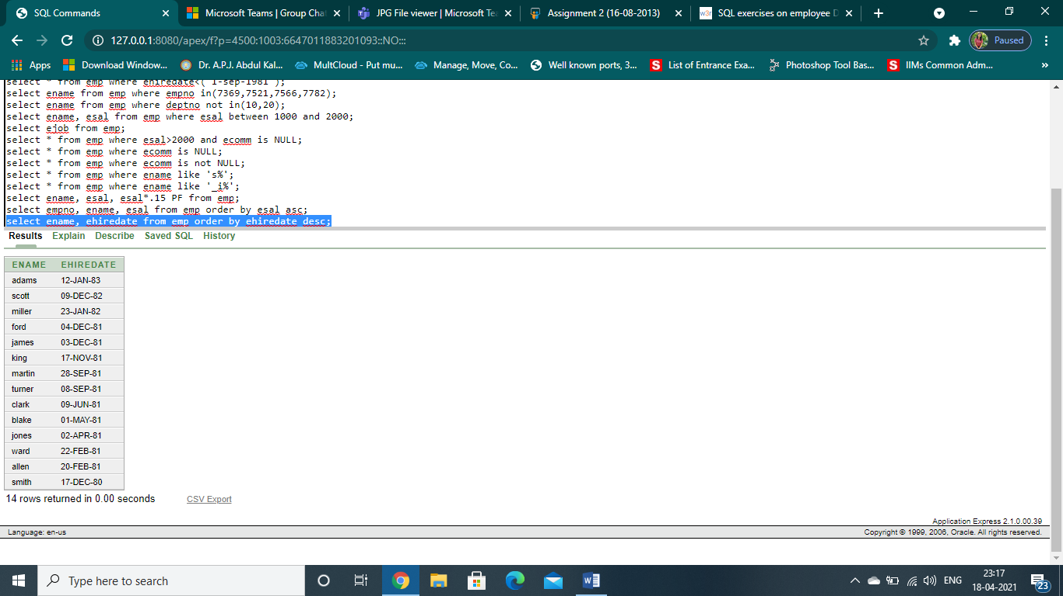

18. List the employee name, salary , job, and deptno in ascending order of department number and then on descending order of salary.

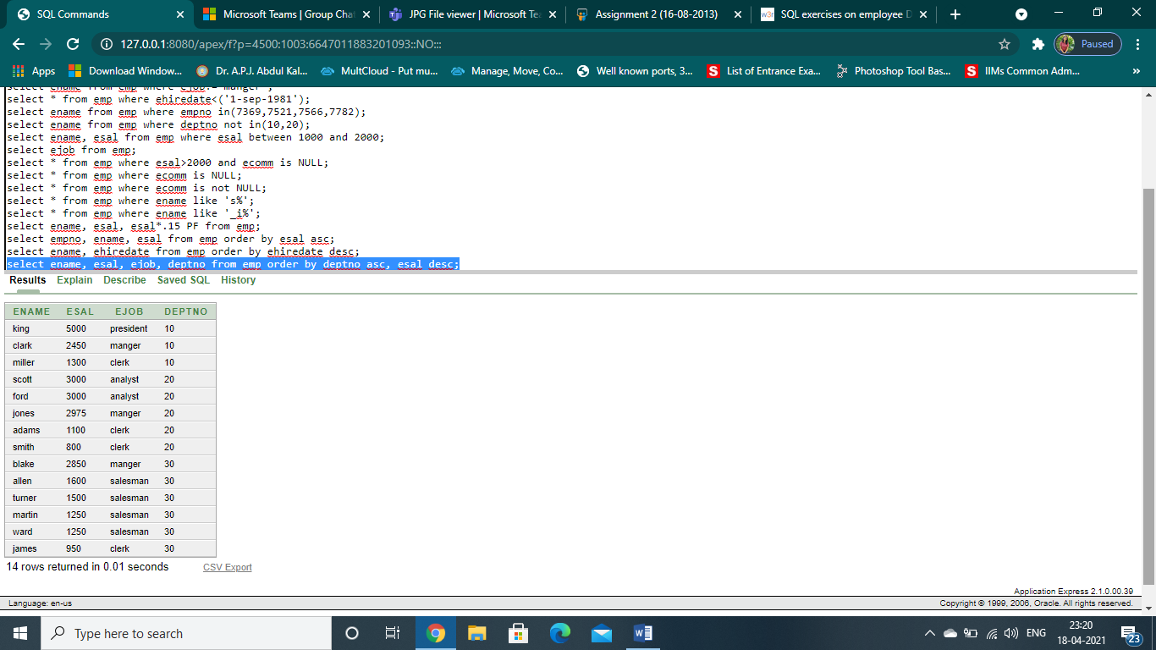

19. List the employee name, salary, PF, HRA , DA and gross ; order the result in ascending order of gross. HRA is .50% of salary and DA is 30% of salary.

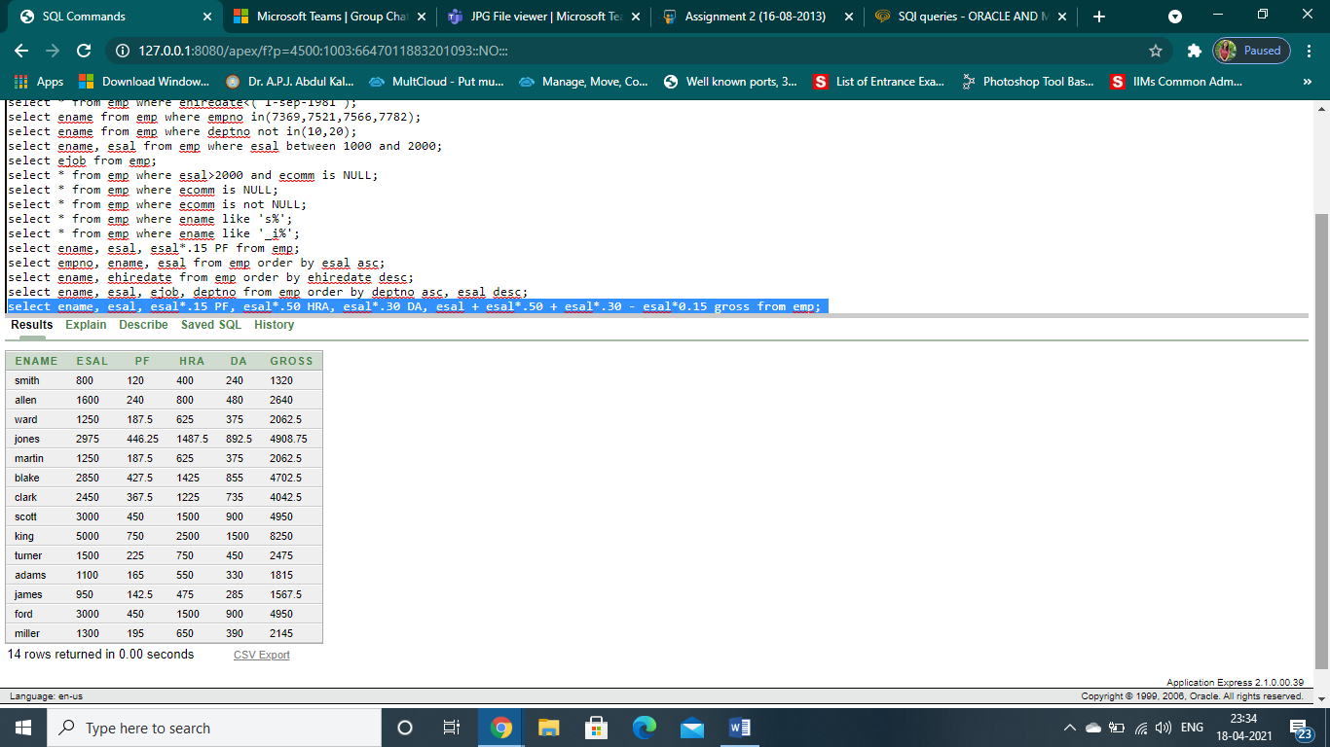

20. List the number of employees working with the company

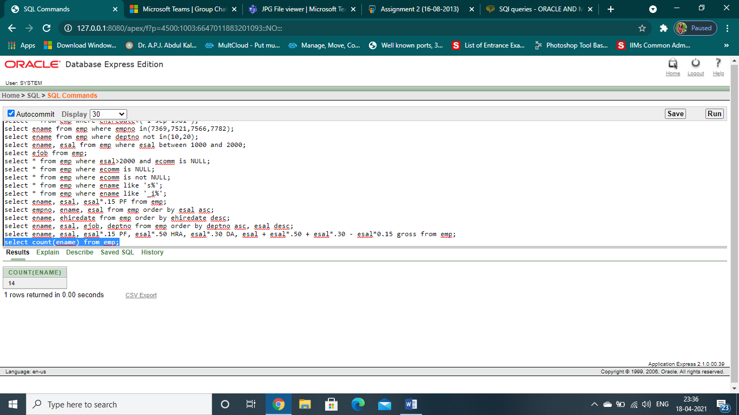

21. List the number of jobs available in the emp table

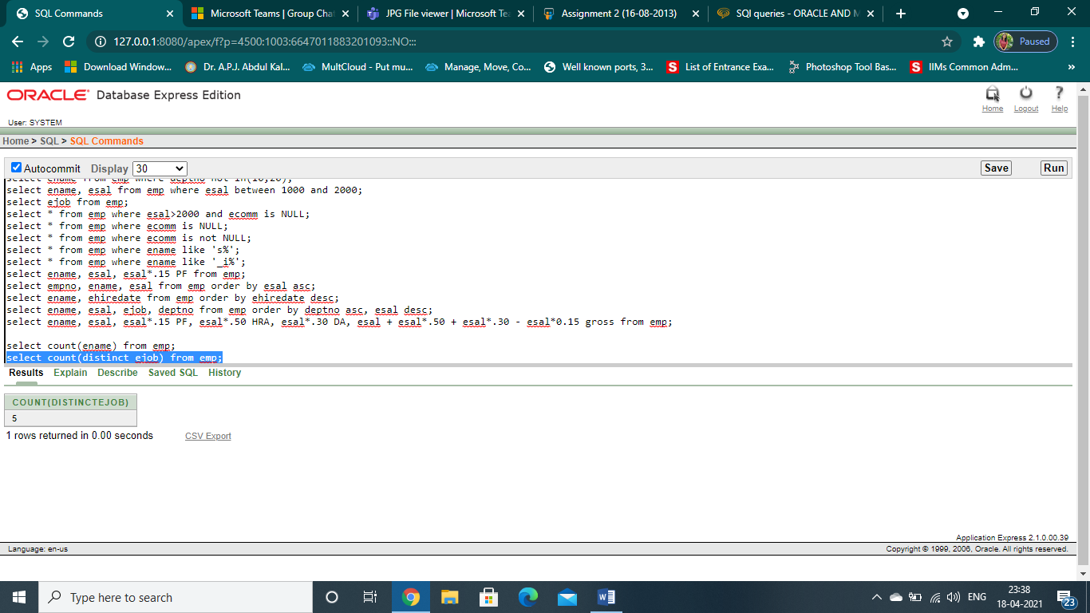

22. List the total salary payable to employees

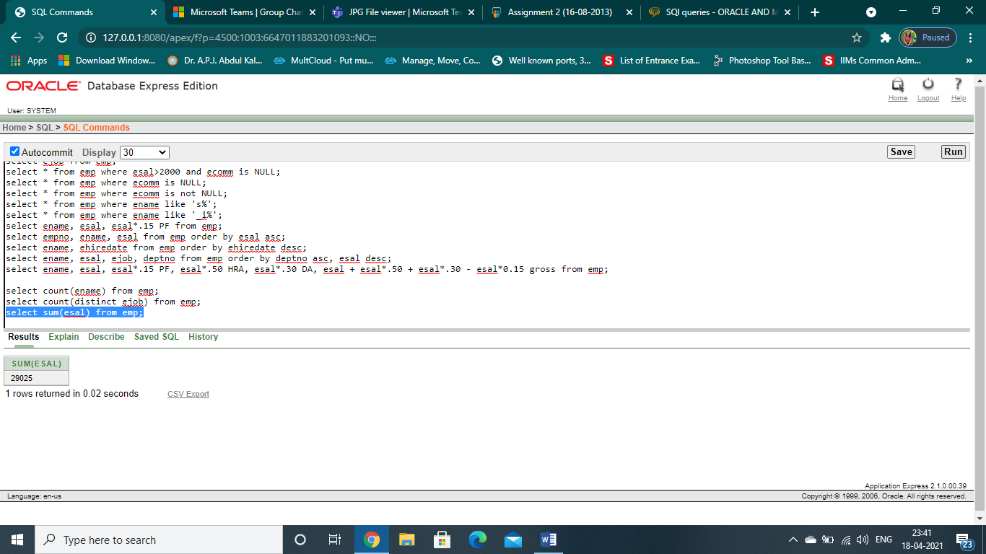

23.List the maximum salary of employee working as a salesman

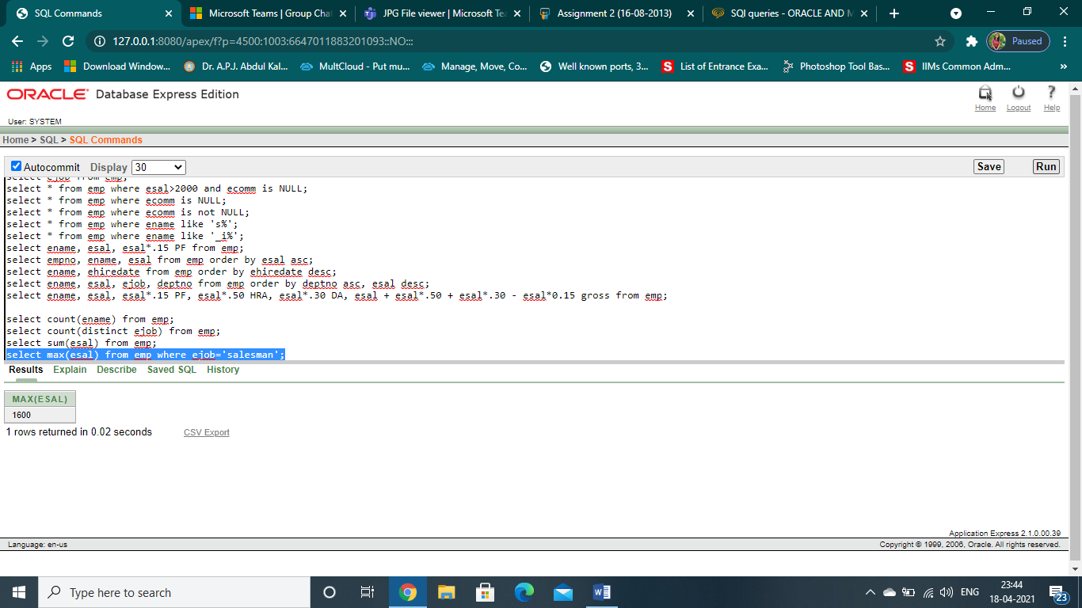

24. List the minimum salary

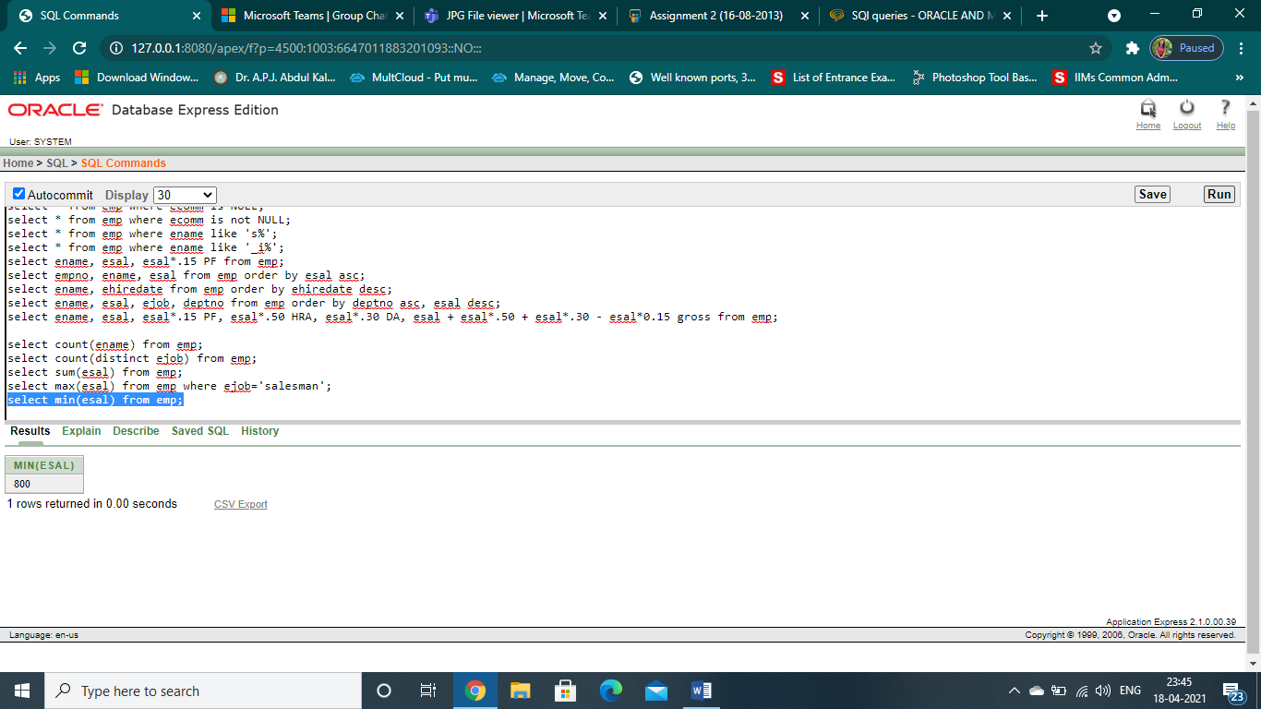

25. List the average salary and no of employees working in the department 20

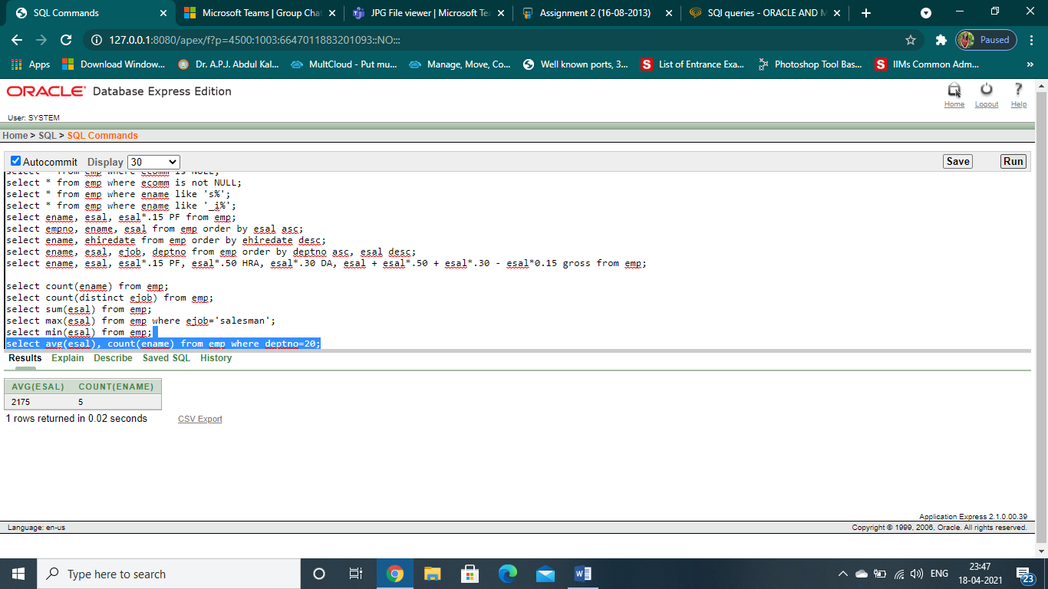

26. List the department no and numbers of employees in each department.

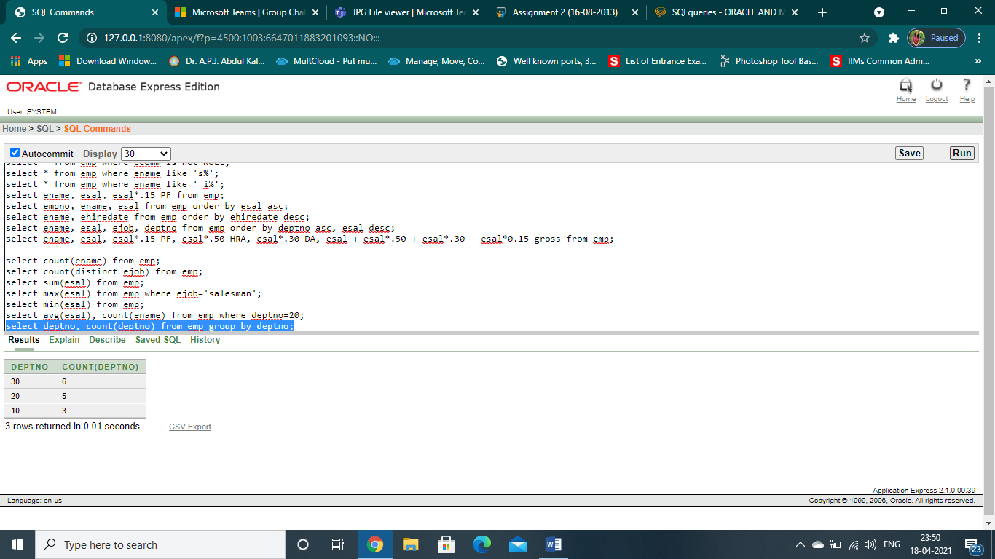

27. List the jobs and the no of employees in each job . the result should be in descending order of the number of employees.

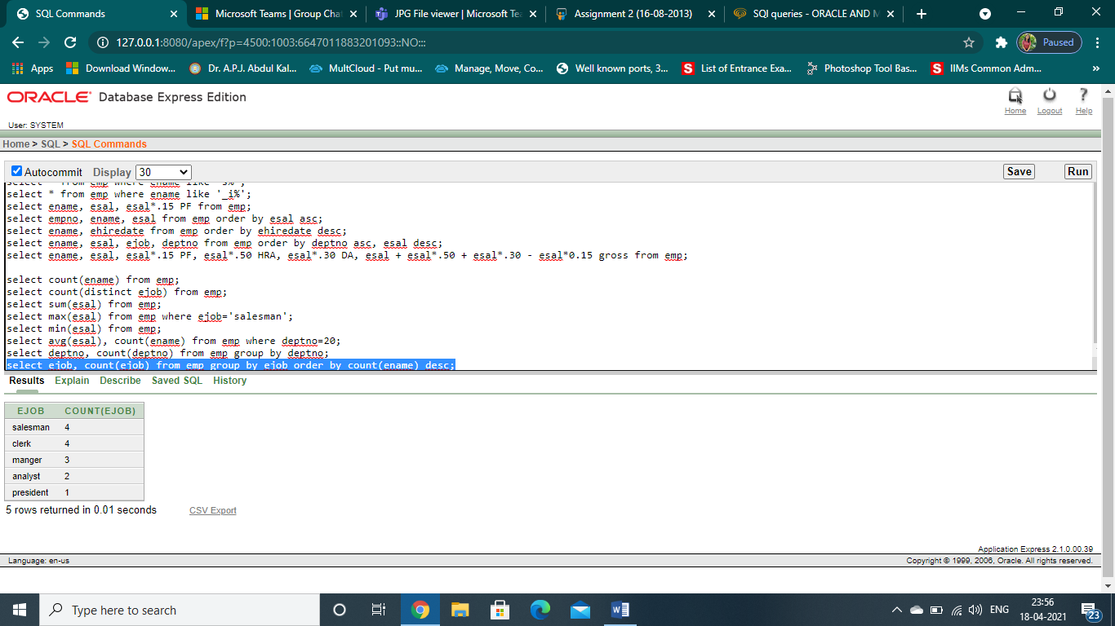

28. List the total salary, maximum and minimum salary of employees job wise

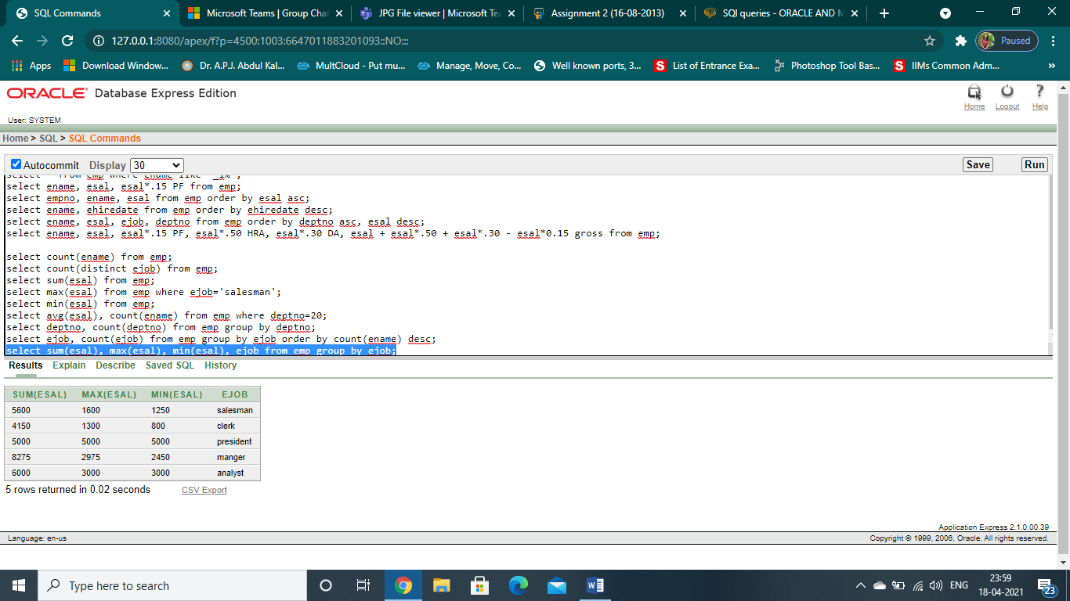

29.List average salary for all the departments employing more than 3 people.

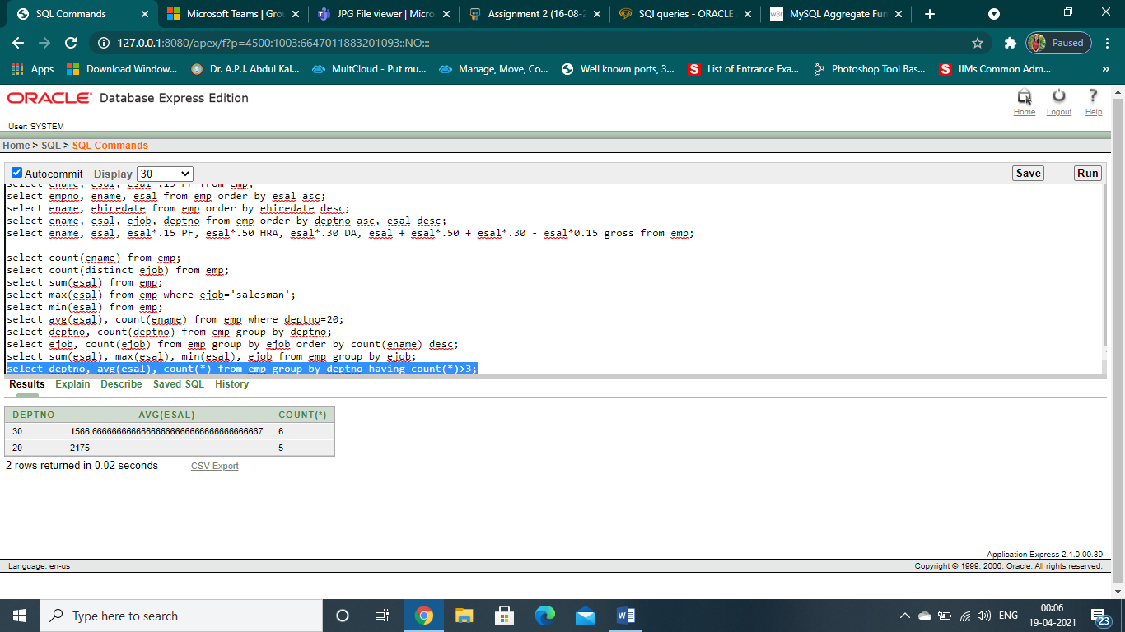

30. List jobs for all employees where maximum salary is greater than or equal to 1000

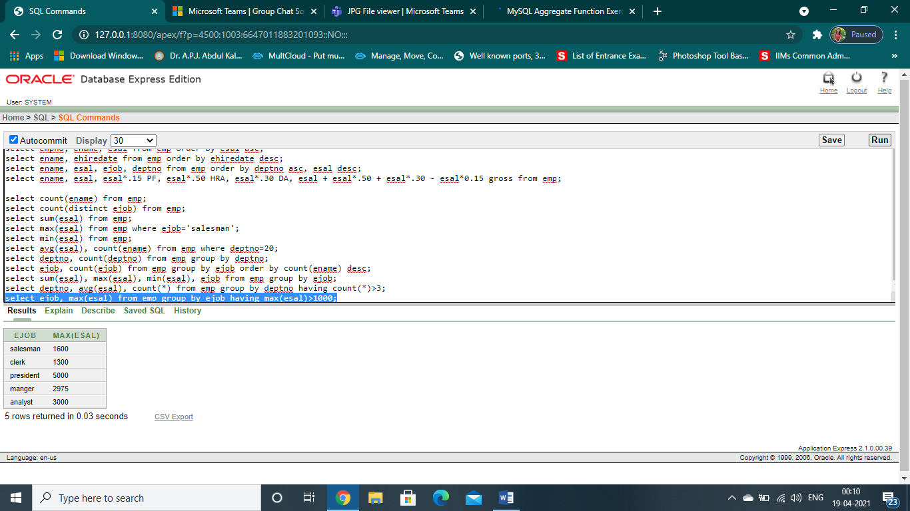

31. List the department number and total salary payable in each department

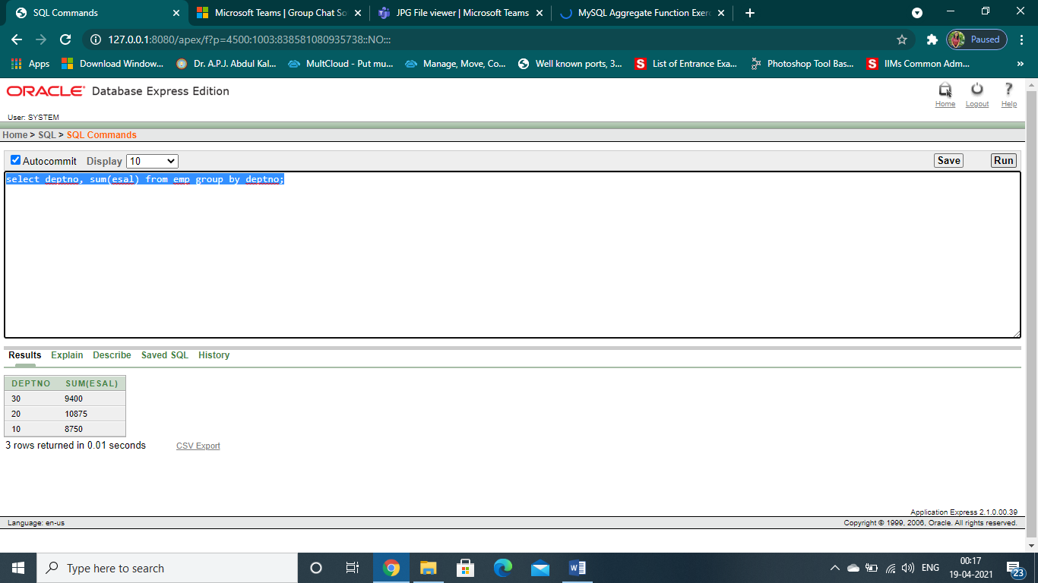

32. List the average salary from each job excluding manager

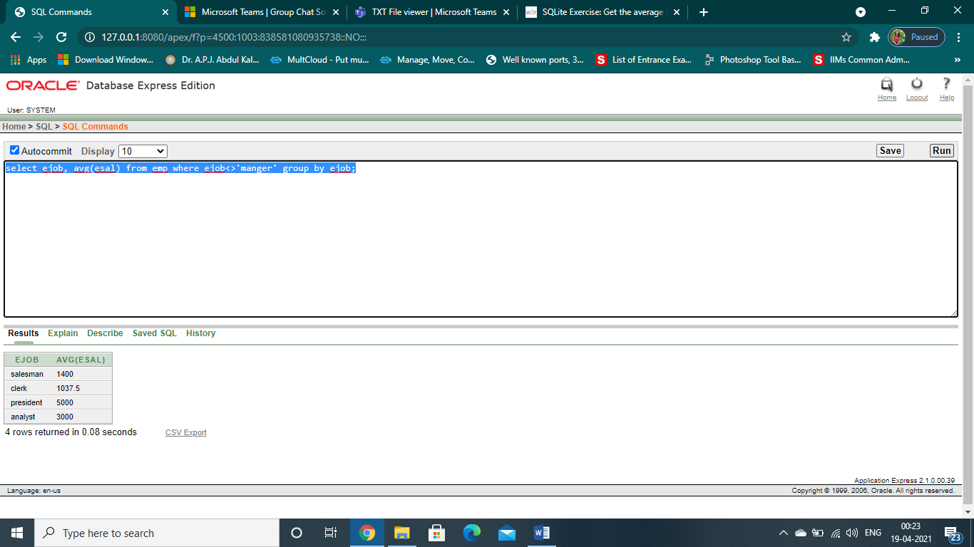

33. List the total salary, maximum and minimum salary and the average salary of employees jobwise for deptno 30 only.

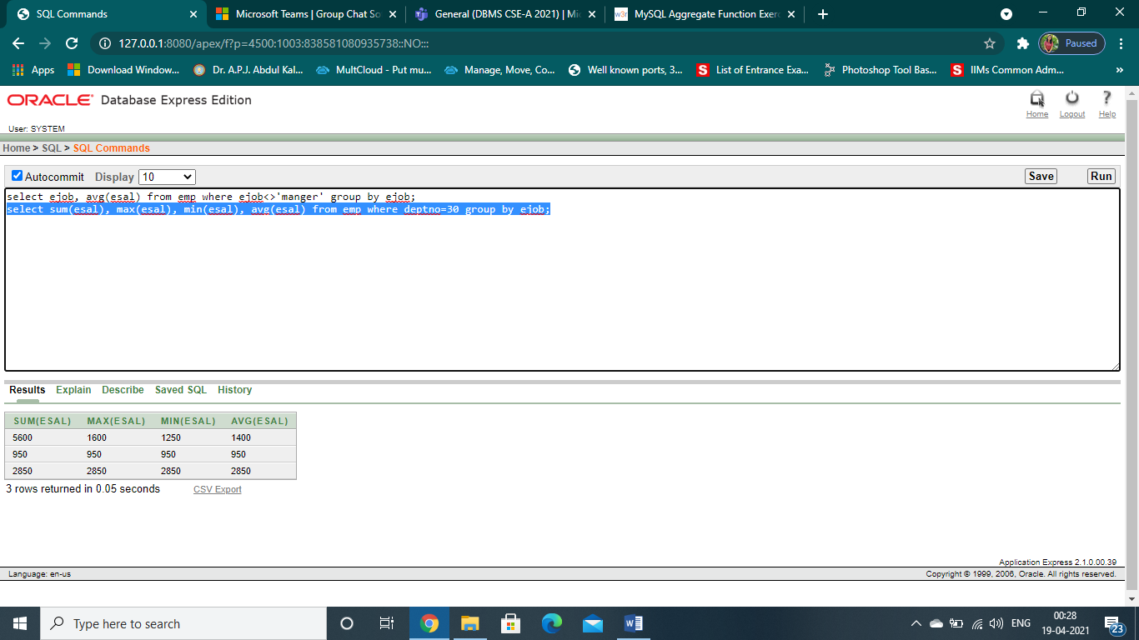

34. List the average monthly salary for each job type within department

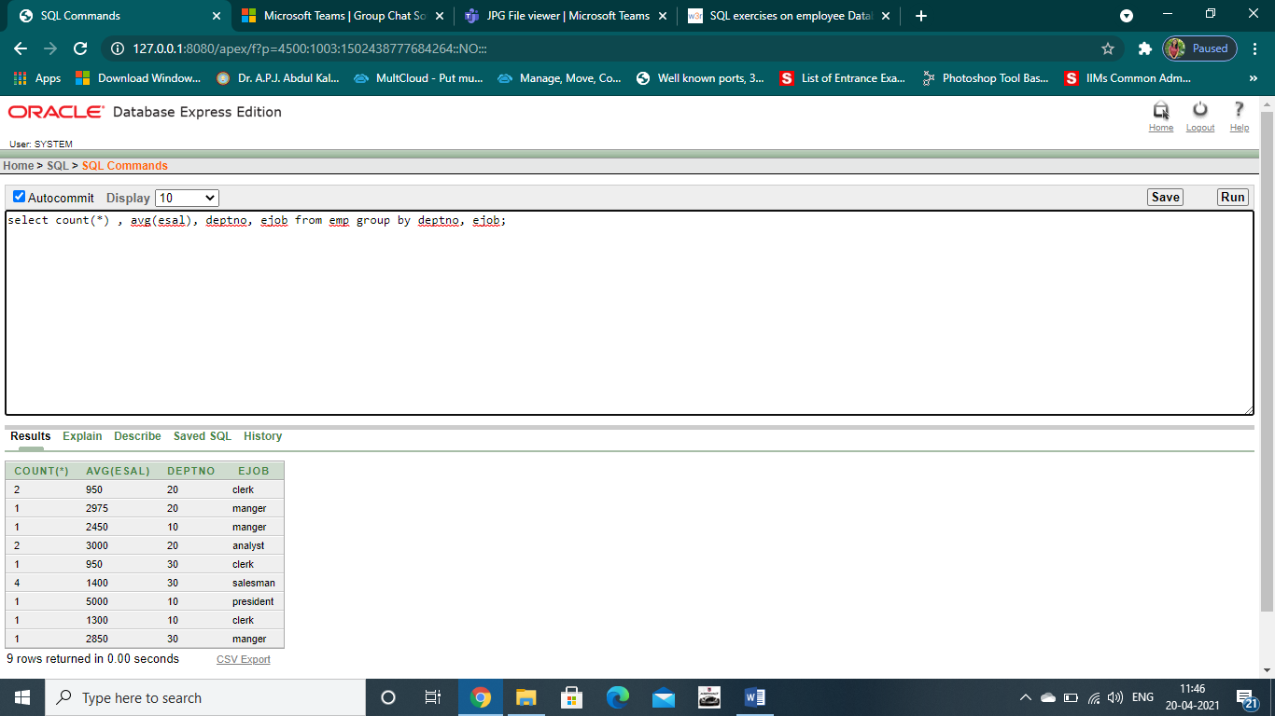

35.List the total salary, max salary, min salary and average salary of employees jobwise for department number 20 and display only those rows having average salary greater than 1000.( arrange the result in ascending order of sum(sal) )

